Requirement
It is a change order. SuiteCommerce Standard.
Customization for web store on checkout, only applicable to the state of California.
ITEM custom fields:
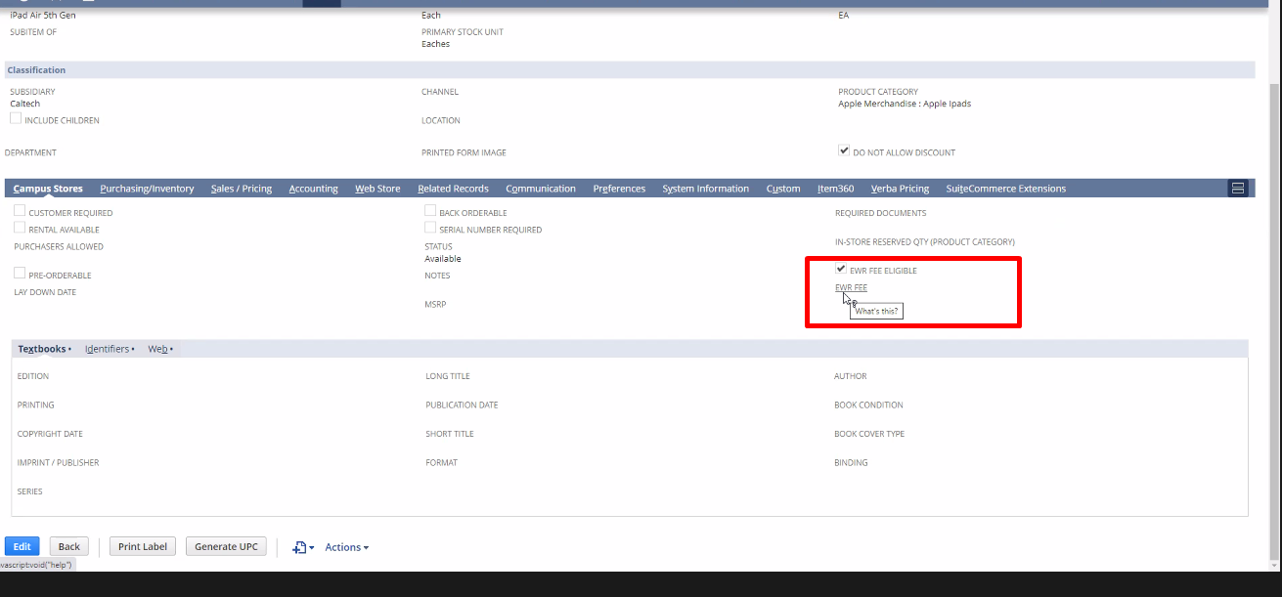
If an item with this custom fields gets added to the cart, then with our customization we will add the “fee” non inventory item to the cart, if the state of shipping is California.
This EWR Fee is a non inventory item that gets added every time an object this eligible fee and is from state of California is added.
Buy online pick up in store does not ask for address, then we will need to use location in store (it will appy for buy online pick up in store).

Si tienen buy online pick up in store NO se puede usar scriptable cart -> usar user event. Parecido water tax, muestra visualmente pero no es.
Piso de 80hs

